Department of Political science
Ambedkar College, Fatikroy
Invited Lecture on Good Governance
On 8th May of 2019 the department of political science, Ambedkar college Fatikroy organized an invited lecture on Good Governance. 105 nos. of students and 13 nos. of faculties from various departments were present in the said lecture programme. Mr. Tapas Chakma, Assistant professor, Department of political science, Government Degree CollegeDharmanagar was the resource person of the programme. He talked about Good governance and its present day relevance. Students were interacting with him after the lecture was over. Mr. Satyajit Das, HOD, department of political science, Ambedkar College was also discussed on the topic briefly. He specially emphasized on the necessity of good governance in present societies. Mr. Tapas Kr. Bhowmik, PGT from the same department made a point on the topic through his speech.
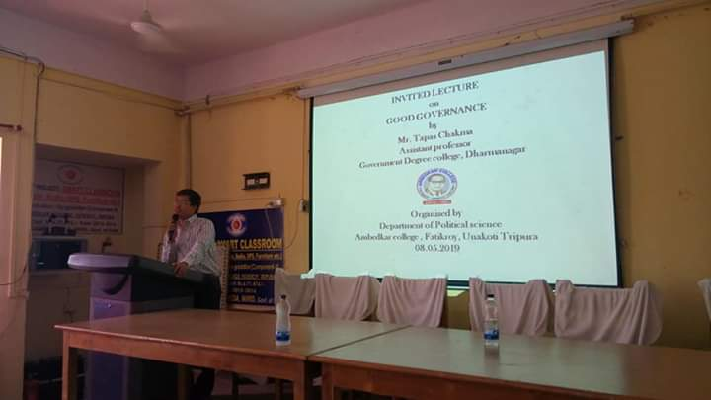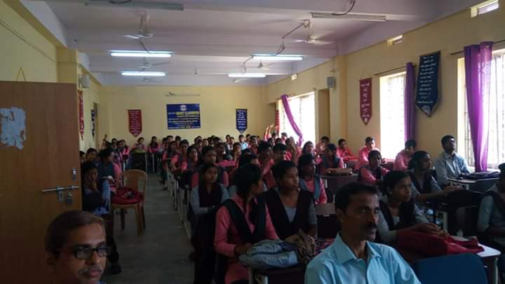
The programme was ended by vote of thanks of Mr. Shyamal Biswas.

